Southern Baptist
Disaster Relief
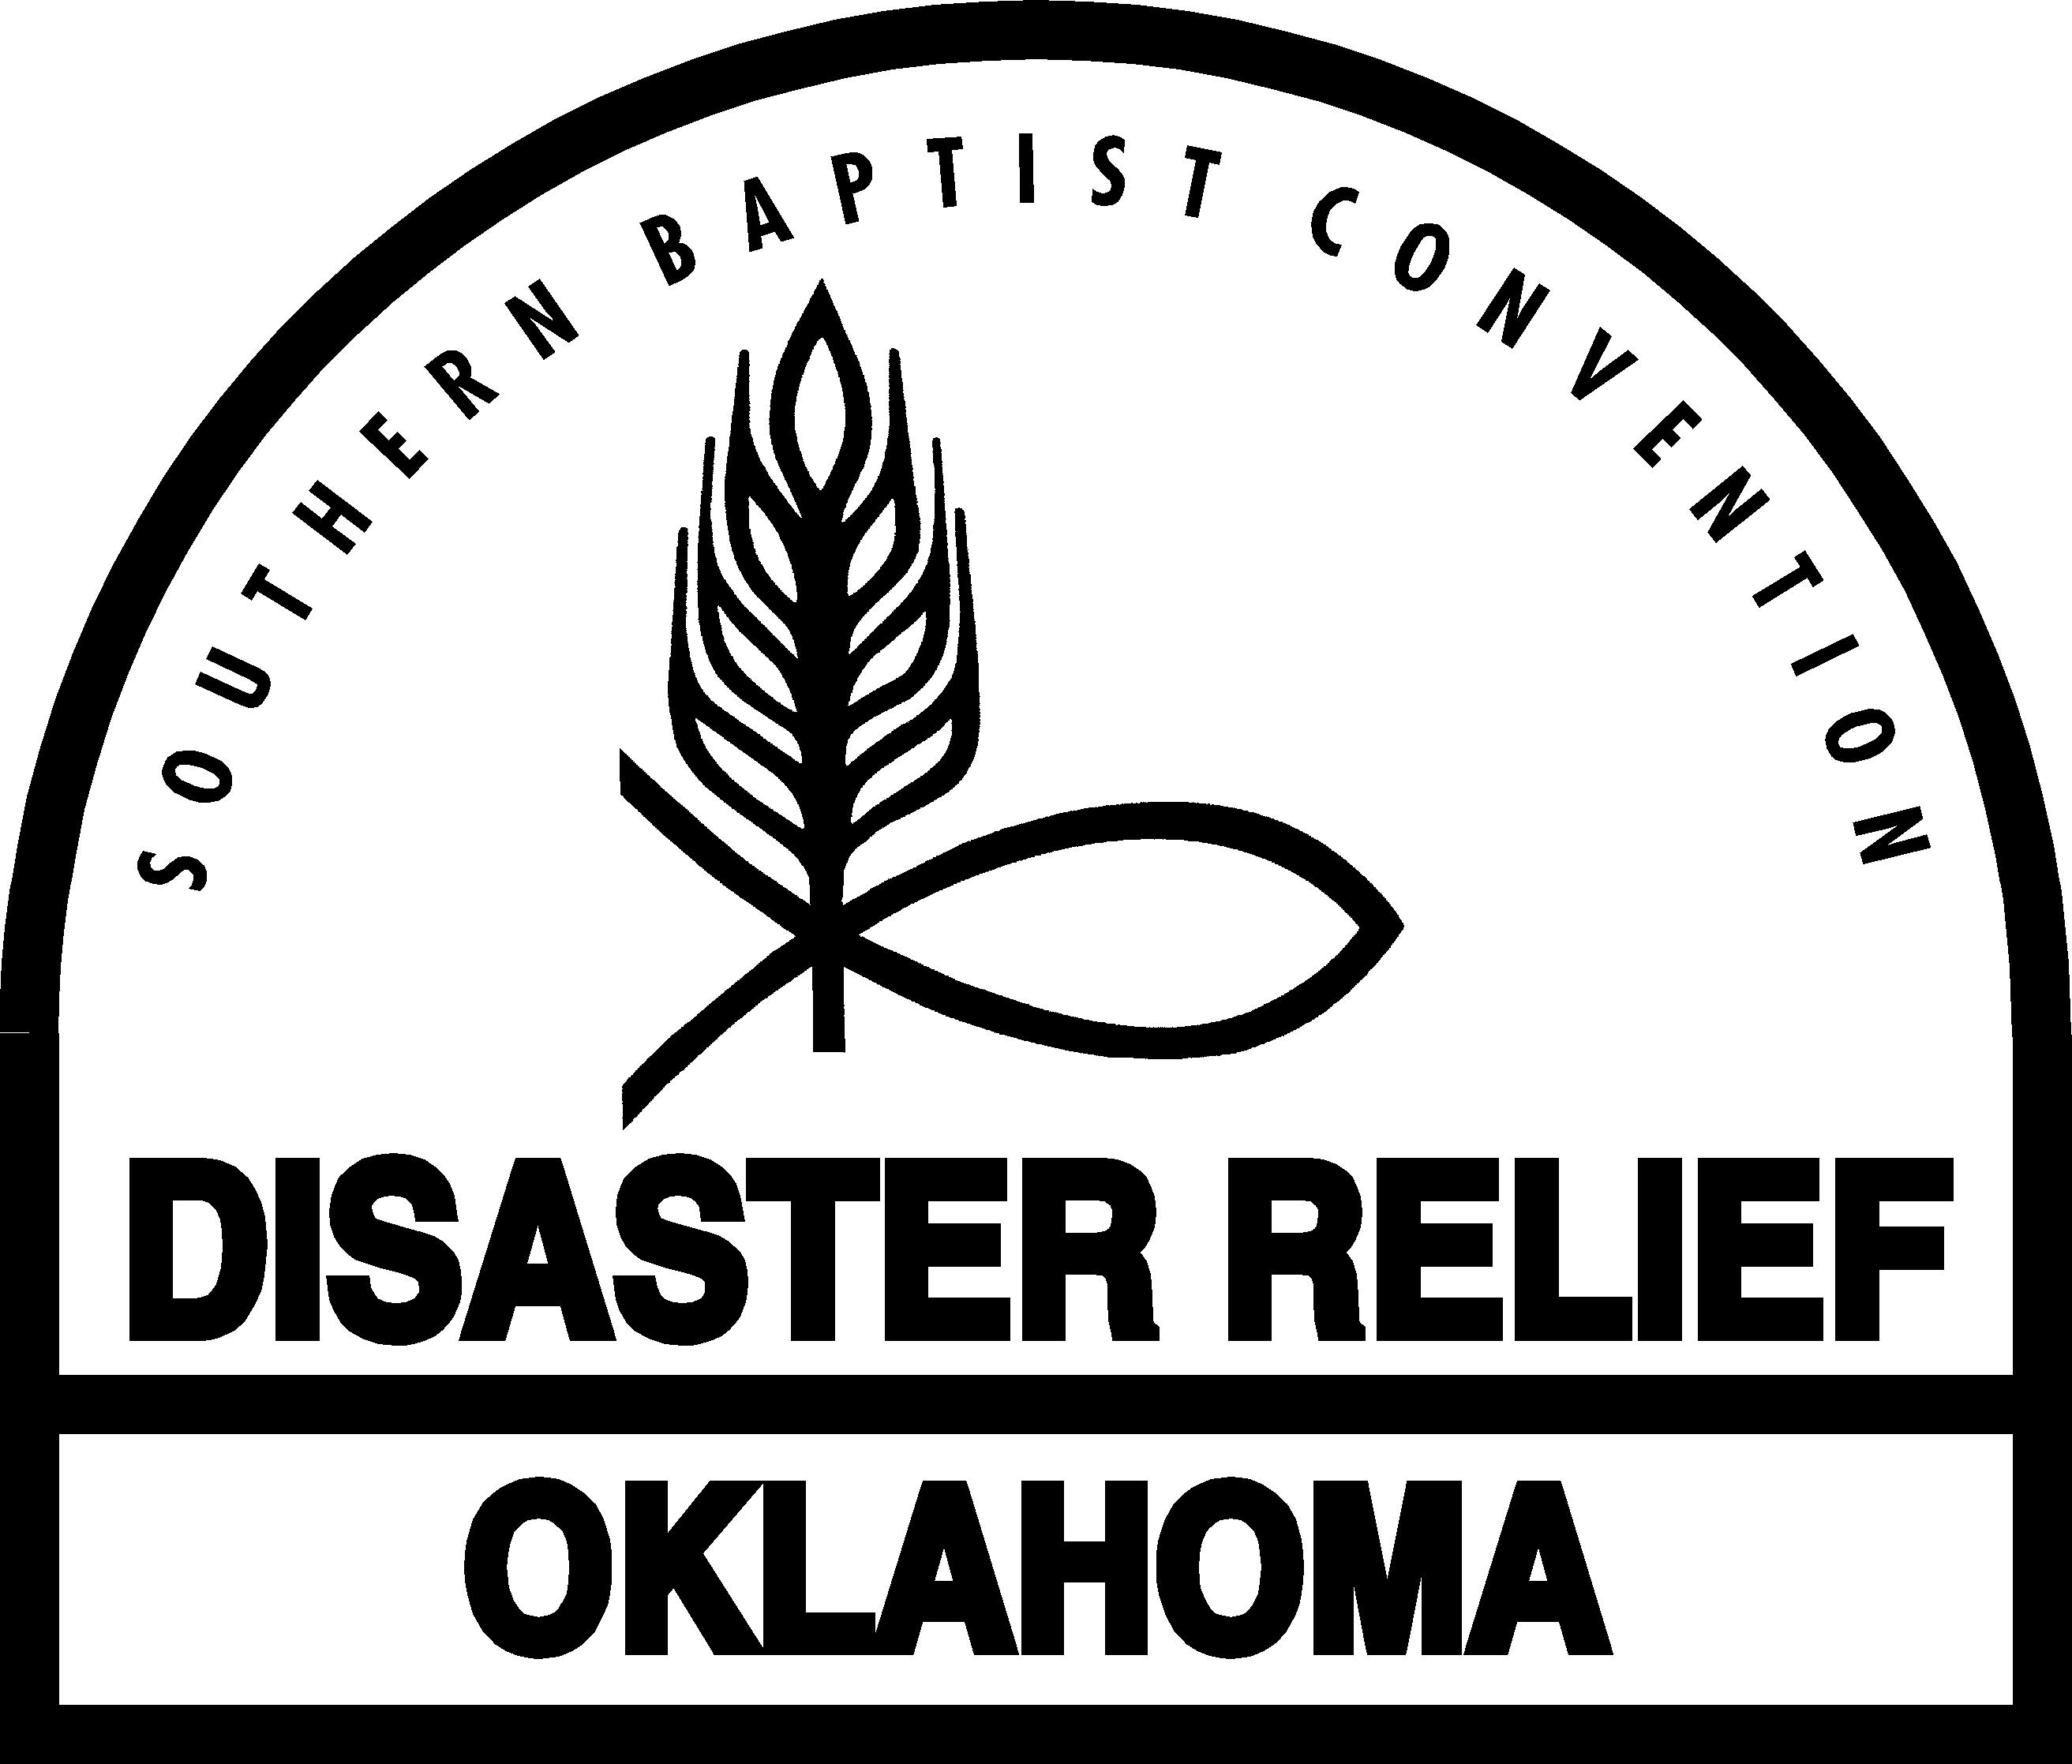

Church Preparedness
for Disaster

3/18/08

Table of Contents

Introduction 1
Churches and Disasters 1
Organizing for Disaster Response 2
Church Disaster Relief Committee 2
Church Disaster Relief Director 3
Church Resources Coordinator 3
Church Volunteer Coordinator 3
Church Disaster Relief Team 4
Church Opportunities and Action 4
Church Preparation 4
Church Approval 5
Appendices
Appendix One: Church Member Disaster Relief Interest and Skills Survey 6
Appendix Two: Church Potential for Disaster Response 7

Churches Ministering In Crisis

Goal: To assist churches to prepare for disaster by developing a strategy to minister to their communities during crisis through preparing their facilities, training their members, securing supplies, and developing protocols that will activate their disaster response plan.

Introduction

A disaster is defined as anything that causes human suffering or creates human needs that the victims cannot alleviate themselves.

A church must plan how it will respond to disasters, large and small, in the community. The plan needs to be well-thought-out and discussed by the church leaders. The people in the congregation need to discuss the plan and determine how they, as individuals, can become part of this ministry.

The unprepared church will miss valuable opportunities to minister if not prepared. By planning before a disaster occurs and coordinating with Southern Baptist Disaster Relief, the local government, The Salvation Army, and local American Red Cross chapter, a church can be prepared to minister fully in a time of crisis.

For example, with proper planning and communication, disaster relief agencies will know that a shelter can be set up in the church facilities and how many people it can accommodate.

Part of the local church's disaster relief plan should consider the needs of individuals and families who have experienced disasters in their lives. These plans might include ministries such as a food pantry, clothes closet, and/or financial assistance.

Church members will find many opportunities to minister in the lives of friends and fellow church members due to disaster.

Churches and Disasters

Local churches are in a unique position to respond to individual needs in ways that no other organization or group can. Churches can demonstrate the love of Christ as they meet the needs of victims in the time of disaster. Even spontaneous reaction to a disaster in or near the church community can be helpful if it is coordinated with the efforts of other disaster relief agencies.

If the church building is in or near the disaster area, there are a variety of ways it can be useful. It can offer the use of its facilities as a feeding center. This center could be a self-contained center utilizing the church kitchen, a Southern Baptist mobile feeding unit, a site for sandwich preparation, or a meal distribution site.

Additional opportunities for a church building to be used in a disaster are as a distribution center for clothing or bulk food items, an information staging area for volunteers or work units; a shelter, a childcare center, a communication center, or an information center for other organizations.

With training church members can provide a ready pool of volunteers to perform any of the above services, whether it’s in the church facilities or not. They can also provide transportation and assist with cleanup and repair. Church members can provide counseling and assistance for special needs.

If the church is not within an affected area, the ministry opportunities will be different. A church’s facility could be a gathering point for food, supplies, building materials, and other items contributed by the community. It could be used as an orientation center for untrained people who have volunteered to help in the disaster area, a shelter for volunteers from outside the area, a staging area for mobile units en route to the disaster site, a communications center, or a command center.

Organizing for Disaster Response

Local churches should work with the state Baptist convention, association, and other congregations and organizations cooperatively, not competitively, while retaining church identify, purpose, and direction. A church should make advance arrangements with these organizations to offer its facilities during an emergency. Plan and work together with a disaster response organization of local churches to reduce omissions as well as duplications. Churches should seek advice and assistance from their state Baptist disaster relief director.

A church disaster relief committee should be elected by the church membership, headed by a church disaster relief director who will give general direction to mitigation, preparation, organization, and training. Other recommended members are the men’s ministry director, the Woman’s Missionary Union director, the missions committee chairman, the pastor, and other staff.

Church Disaster Relief Committee

The disaster relief committee should perform the following functions:
- Conduct a survey of church members’ skills, gifts, talents, and willingness to serve.
- Provide regular training.
- Lead the church to approve making facilities and equipment available for disaster relief ministries.
- Begin and maintain a crisis closet, food pantry, etc.
- Secure approval of the church to cooperate with other local churches, the association, state disaster relief director, The Salvation Army, American Red Cross, emergency management agencies, and other civic and government agencies.
- Contact government and American Red Cross authorities for the names and contact information of those who will direct disaster operations.
- Be alert for local and nearby crises that present the church opportunities to witness and minister through disaster relief. These may be large scale crises such as tornadoes, floods, and winter storms. Short-term crises such as fires in single family dwellings, accidents, vandalism, and acts of crime are also opportunities to minister. Churches should report any actions and register them with local authorities, the Baptist association, and the state disaster relief director.
- Identify and assign volunteers according to the talent sheets.
- Conduct damage assessment in the community and notify local, associational and state disaster relief directors.

Responsibilities of church disaster relief leaders:

Church Disaster Relief Director
- Trained by the state Baptist convention disaster relief ministry.
- Chair the disaster relief committee.
- Assemble a church disaster response team.
- Schedule planning and preparation meetings and activities.
- Schedule training events for volunteers.
- Enlist a church resources coordinator, help establish a plan of action, and assist in carrying out duties described below.
- Enlist a church volunteer coordinator, help establish a plan of action, and assist in carrying out duties described below.
- Serve on planning and coordinating groups before, during, and after a disaster.
- Relate to the local American Red Cross chapter, The Salvation Army, and government authorities.
- Relate to state convention and association disaster relief director.
- Alert coordinators and the church disaster relief committee of opportunities to minister.
- Prepare the church disaster team to respond.

Church Resources Coordinator
- Trained by the state Baptist convention disaster relief ministry.
- Conduct an inventory of building facilities, equipment, supplies, and vehicles that might be used during a disaster. Adapt forms provided in appendix for that purpose
- Determine what to recommend to the church regarding the use of facilities, supplies, and equipment during a disaster, along with the committee.
- Enlist volunteers to assist with plans adopted by the church regarding the use of church facilities and equipment.

Church Volunteer Coordinator
- Trained by the state Baptist convention disaster relief ministry
- Conduct a skills and talent survey of the church membership. Adapt forms provided in appendix.
- Develop a database of volunteers and skills, contact information, and training completed.
- Arrange for orientation and training of volunteers.
- Organize teams by skills. Choose team leaders.
- Establish a telephone chain for notifying volunteers when a response is possible.
- Activate the church disaster relief telephone chain when needed.
- Gather volunteers at the church or other location for assignment to duties and work locations.
Church Disaster Relief Team
- Trained by the state Baptist convention disaster relief ministry
- Open church as a shelter to victims or volunteers.
- Prepare vehicles for a response.
- Assist in evacuation of families that may need help.
- Check on the elderly and others that may need help before and following a crisis.
- Clear church parking lot of debris following a disaster.
- Assist families as need in keeping with the church disaster plan.
- Provide temporary child care relief and/or elder care.

Church Opportunities and Action

A church can assist with mitigation, preparation, warning, rescue and evacuation. It can also provide facilities, volunteers, and supplies to assist with emergency feeding, shelter, child care, or other functions. Church facilities can be used as an information center for victims and also provide pastoral counseling or crisis intervention.

Other ministry opportunities for churches are to:
- Identify volunteers (in the church or in the community) who can give advice regarding insurance, repair contracts, and applications for loans or grants.
- Locate qualified people to care for children, the elderly, and sick or disabled people who need special facilities, diets, transportation, and/or recreation.
- Identify members who can provide temporary housing for victims.
- Identify bilingual interpreters to assist those who speak another language or have literacy limitations.
- Provide companionship to people who have been displaced and are unfamiliar with their new surroundings, community services, and stores.
- Participate in ministries such as receiving, sorting, and distributing clothing, bedding, bulk food, clean-up, and household supplies.
- Provide assistance with food, housing, communication, and other needs of out-of-town volunteers who come to help with the disaster response.
- Cooperate with other agencies during disasters
- Have a voice in the rebuilding/relocation process and make sure victims are treated the same in regard to physical, social, and spiritual recovery.
- Begin a transportation bank by developing a database of cars, vans, pickups, dump trucks, boats, planes, ATV’s, etc. which might be available during a disaster.
- Organize clean-up, salvage, security or repair crews, as well as help victims clean their homes and furniture, install temporary roofing or board up windows and doors or remove household contents for safe storage.

Church Preparation

Churches should take the time to develop a plan before disaster strikes. If no advance preparation has been made, ministry opportunities will be limited.
Consider the following suggestions as you organize your church in disaster relief:
- Pray! Pray before, during, and after each of the following steps.
- Discuss the idea with the pastor.
- Complete the checklist entitled Church Potential for Disaster Response at end of manual.
- Discuss the possibilities with the men’s ministry director. If this position does not exist, establish one or talk to another group in the church that might take the lead.
- Consider finances. How will the ministry be paid for?
- Be ready to recommend a leadership team—people willing to work and willing to enlist others to do so.
- Discuss ways the ministry might be used in the community or how it will contribute to state and associational disaster relief.
- Contact the associational director of missions, associational men’s ministry director, and the state disaster relief director for suggestions and guidance.
- Make a list of possible services. Try to find out what other churches have done and give examples.
- Contact the local American Red Cross, The Salvation Army, and the county emergency services agency for information on how the church can help in case of a disaster.
- Select one or more services to recommend to the church or get input from other church members in deciding on a ministry.

Church Approval

The next step is to secure church approval. The proposal for church authorization may come from an individual, but it would be best if it came from a church organization.

Organize the presentation. Present all pertinent facts, whether they are positive or negative. Develop a mission statement. Tell why the ministry is needed and why the church is capable of accomplishing it. Present the proposal in the form of a motion, either to authorize developing a specific ministry or to recommend further study to bring a definite recommendation later.

Cooperate with other agencies to:
- Reach an agreement with state or associational disaster relief ministries.
- Arrange for training.
- Reach agreement with other agencies in disaster response within your community.
- Secure permits, codes, licenses, certification, insurance, etc.
- Prepare a report to the state or associational disaster relief director, local disaster relief agencies and emergency management agency, or other organizations that you will support.
Appendix One
Church Member Disaster Relief Interest and Skills Survey

Name ________________________________________________________________________
Street Address ____________________________ Home Phone ________________________
City/State/Zip ____________________________ Work Phone ________________________
E-mail ____________________________ Cell Phone ________________________

Church ____________________________ Phone ______________________________
Address __________________________________________________________________

Would you be interested in assisting with a disaster relief project by our church:
____ In this community ____ In this county ____ In this state ____ In the USA ____ Internationally

How much lead-time would you need to get ready to participate in a project?
______________________________________________________________________________

Interest/Experience/Training

Check the types of disaster ministries that interest you. Place two checks by areas where you are experienced.

__1. Advisory/advocacy
__2. Bulk distribution
__3. Casework
__4. Chainsaw crew/tree removal
__5. Child care
__6. Cleanup crew
__7. Communications (Ham Radios)
__8. Counseling
__9. Crisis closet
__10. Damage assessment
__11. Elder care (or handicapped)
__12. Employment assistance
__13. Evacuation of persons
__14. Feeding
__15. Interpreter: Language___________
__16. Legal aid
__17. Literacy
__18. Medical emergency team
__19. Mud-outs
__20. Reconstruction team
__21. Repair (emergency)
__22. Salvage
__23. Sanitation
__24. Security
__25. Shelter management or care
__26. Transportation
__27. Other___________________

Check if you have training in the following:
__ Involving Southern Baptists in Disaster Relief
__ State disaster relief manual
__ Hands-on training with unit
__ Temporary emergency child care
__ Crisis counseling

__ American Red Cross
__ Introduction to Disaster Services
__ Mass Feeding
__ Advanced first aid and CPR
__ Other
__ Other disaster relief training

Appendix Two

Church Potential for Disaster Response

The following may be used in a disaster response in or near our community.

A. Church Facilities
___ classrooms
___ clothes bank
___ dining room
___ dumpster
___ fellowship hall
___ food bank
___ gymnasium
___ kitchen
___ nursery
___ outside electric hookup
___ outside swage
___ outside water hookup
___ rest rooms
___ showers
___ storage building
___ vacant building
___ other ___________

B. Equipment
___ air compressor
___ chainsaws, etc.
___ generator
___ high volume pump
___ oxygen tank
___ portable stoves
___ sanitation equipment and supplies
___ submersible pump
___ other ___________
C. Vehicles
___ 4x4’s
___ aircraft
___ ATV
___ boats
___ buses
___ campers
___ tractor-trailer
___ trailers
___ trucks
___ van
___ other___________

D. Tools and Supplies
___ wheelchair
___ brooms
___ cots
___ crutches
___ electric cords
___ first-aid kit
___ garden hose
___ hand tools
___ mops
___ power tools
___ shop vacuum
___ shovels
___ other _____________

7

